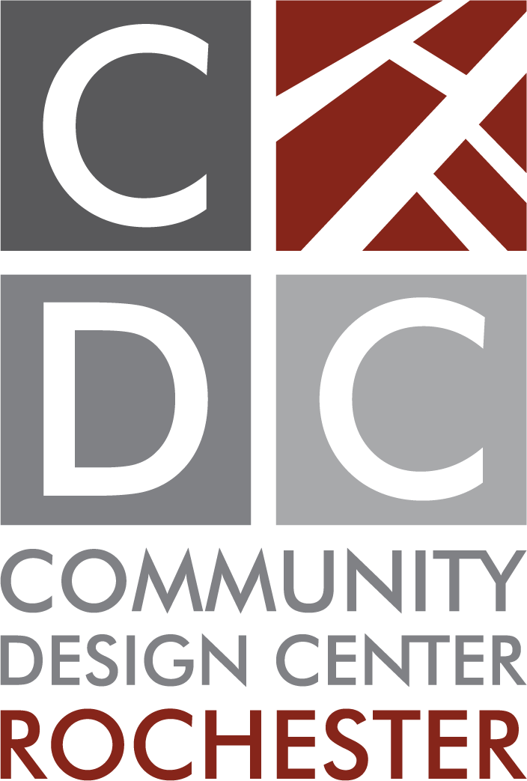
Design Manager Position
Posted June 24, 2024

The Community Design Center Rochester (CDCR) is looking to hire a tech savvy Design Manager to join our mission-based non-profit team.

The CDCR promotes healthy, sustainable communities by encouraging quality design of the built environment and thoughtful use of built and natural resources. CDCR advocates for good design in the Greater Rochester Region.

The Design Manager is a regular part-time hourly position, 24-32 hours per week. A minimum of 24 hours per week shall be performed in the CDCR office. Flexible hours for candidates with families. The CDCR will provide a VPN connection for work performed remotely. Occasional attendance at meetings and events occurring outside of the normal established hours will be required.

Working under the supervision of the (Acting) Executive Director, the Design Manager will work as a team member with CDCR staff members, consultants, volunteers, and interns to coordinate, plan, and execute projects, programs, and initiatives for the Community Design Center and its community clients. This work will include research, compiling information, designing, writing reports, and mapping; preparing and giving presentations; creating and executing drawings, graphics, and materials for projects; coordinating, promoting, and facilitating meetings, design workshops, and other CDCR events. The Design Manager will also provide support for a variety of CDCR initiatives including helping to plan and coordinate the annual fundraising campaign, the annual Reshaping Rochester Speaker Series and Awards event.

Requirements:
Undergraduate or graduate degree in Planning, Landscape Architecture, Architecture or Environmental Design with some experience and a strong interest in urban design and placemaking. The ideal candidate will possess sound abilities in time management, organization, design, and visual and verbal communication. The position requires a desire and ability to work with community groups and a commitment to civic engagement and participatory citizen-based planning. Candidate must possess the ability to work independently and see projects through from inception to completion, while collaborating with a wide range of stakeholders.

Technical Skills:
- Proficiency in Microsoft Office Suite, Adobe Creative Suite (InDesign, Photoshop) and preferably experience with ArcGIS, AutoCAD, SketchUp or other modeling software.
- Experience with social media platforms such as LinkedIn, Instagram / Facebook and YouTube is helpful;
- Experience with email marketing software (Constant Contact & Eventbrite) is helpful;

To apply, email a cover letter and resume to: admin@cdcrochester.org or call (585) 271-0520.

